







BugID: bug_01

[Showing wrong status code when required fields are not provided.]

**Description:**

**Package Name:** Evaluation

**Module Name:** Get Evaluation

**Method:** GET

**Endpoint:** /api/v1/evaluation?batchId={batchId}&taskType={TASK_TYPE}

**Base URL:** http://localhost:8080/

*Environment *

OS: Windows 10 pro

Browser: Chrome Version 118.0.5993.71 (Official Build) (64-bit)

Build Date: 2023-10-18

**Pre-Conditions**

1. The system is up and running, and the API is accessible.
2. Admin/ Trainer must be logged in

# Steps to reproduce

1. Send a GET request to the endpoint /api/v1/evaluation without providing the required parameters (batchId, taskType).

# Expected Result

1. The API should respond with a status code of 400 (Bad Request) since the required parameters are missing.

# 2. The response should contain an error message indicating the missing parameters.

# Actual Result

1. API and response body shows a status code 403 FORBIDDEN. But API should respond with a status code of 400 (Bad Request) since the required parameters are missing.

2. The response body does not contain an error message indicating the missing parameters.

**Attached Document:**

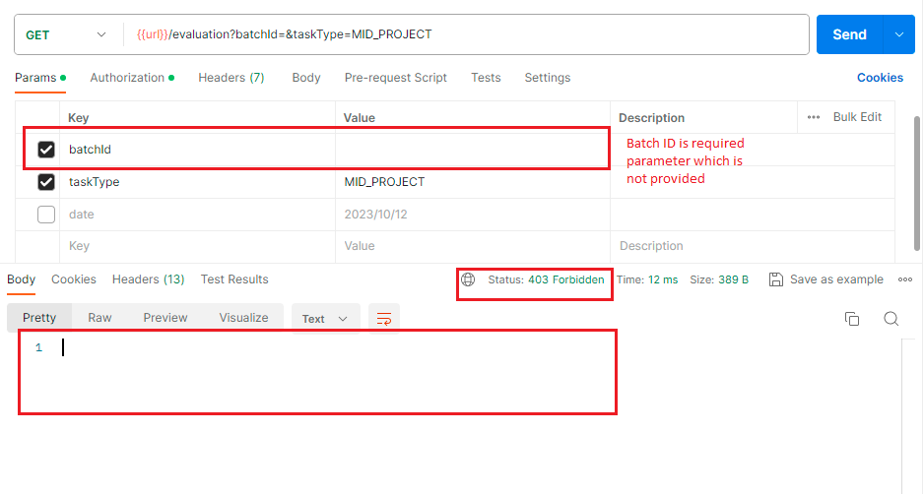

BugID: bug_02

[API provides invalid response status code a non-existing batch ID is provided]

**Description:**

**Package Name:** Evaluation

**Module Name:** Get Evaluation

**Method:** GET

**Endpoint:** /api/v1/evaluation?batchId={batchId}&taskType={TASK_TYPE}

**Base URL:** http://localhost:8080/

*Environment *

OS: Windows 10 pro

Browser: Chrome Version 118.0.5993.71 (Official Build) (64-bit)

Build Date: 2023-10-18

**Pre-Conditions**

1. The system is up and running, and the API is accessible.
2. Admin/ Trainer must be logged in

# Steps to reproduce

1. Send GET request to endpoint /api/v1/evaluation?batchId=2&taskType=MID_PROJECT
2. Enter invalid batchId and valid taskType in the path variables as Query params

# Expected Result

1. HTTP status code should be 404 NOT FOUND.

2. The response should contain an error message.

# Actual Result

1. API and response body shows a status code 200 OK. HTTP status code is not 404 NOT FOUND.

2. The response body does not contain an error message indicating the Batch ID does not exist.

**Attached Document:**

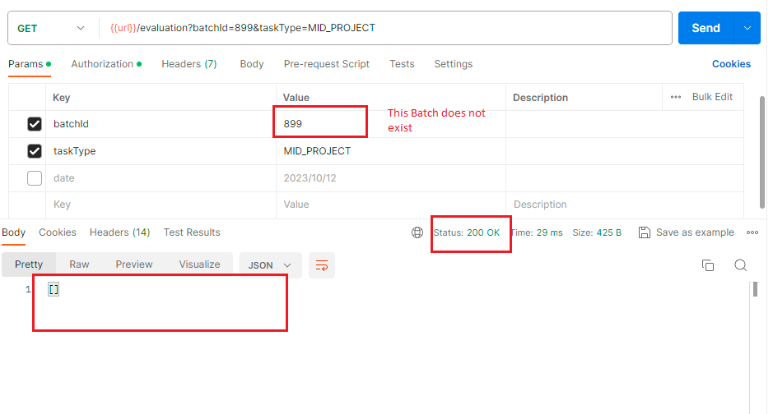

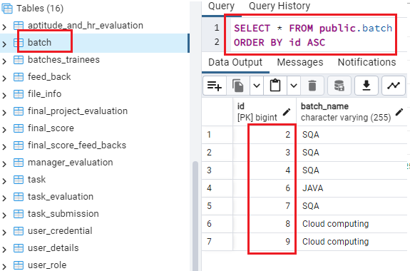

BugID: bug_03

[API provides invalid response status code when valid task type is not provided]

**Description:**

**Package Name:** Evaluation

**Module Name:** Get Evaluation

**Method:** GET

**Endpoint:** /api/v1/evaluation?batchId={batchId}&taskType={TASK_TYPE}

**Base URL:** http://localhost:8080/

*Environment *

OS: Windows 10 pro

Browser: Chrome Version 118.0.5993.71 (Official Build) (64-bit)

Build Date: 2023-10-18

**Pre-Conditions**

1. The system is up and running, and the API is accessible.
2. Admin/ Trainer must be logged in

# Steps to reproduce

1. Send GET request to endpoint /api/v1/evaluation?batchId=2&taskType=MID_PROJECT
2. Enter valid batchID and invalid taskType in the path variables as Query params

# Expected Result

1. HTTP status code should be 404 NOT FOUND.

2. The response should contain an error message.

# 

# Actual Result

1. API and response body shows a status code 403 FORBIDDEN. HTTP status code is not 404 NOT FOUND.

2. The response body does not contain an error message indicating this task type does not exist.

**Attached Document:**

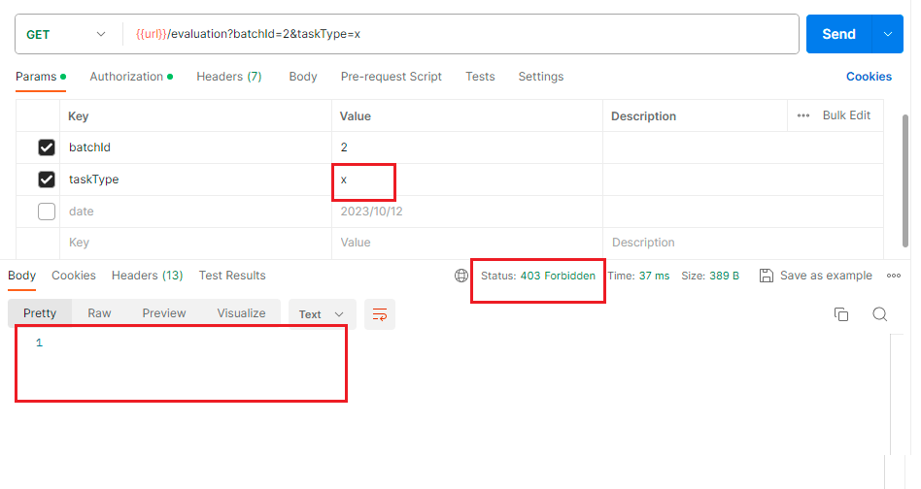

BugID: bug_04

[Upon creating a batch using the API, the trainee input field takes data from request body but in response body, trainees field don’t get updated and added to the batch ]

**Description:**

**Package Name:** Batch

**Module Name:** Create Batch

**Method:** POST

**Endpoint:** /api/v1/batch.

**Base URL:** http://localhost:8080/

*Environment *

OS: Windows 10 pro

Browser: Chrome Version 118.0.5993.71 (Official Build) (64-bit)

Build Date: 2023-10-18

**Pre-Conditions**

1. The system is up and running, and the API is accessible.
2. Admin must be logged in

# Steps to reproduce

1. Send a POST request to the endpoint /api/v1/batch.

2. Capture the response and check the validity of data for each field.

# Expected Result

1. Response data should be correct and show every field from the input.

# 

# Actual Result

1. Trainee field is not showing the response as per the input

**Attached Document:**

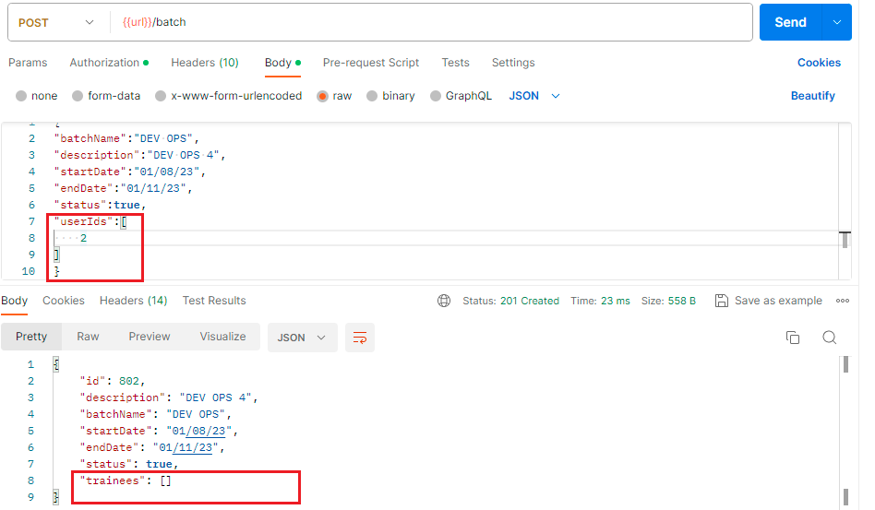

BugID: bug_05

[Upon creating a task using the API, the batchID input field takes non-existing batchID data from request body and gets updated in the database ]

**Description:**

**Package Name:** Task

**Module Name:** Create Task

**Method:** POST

**Endpoint:** /api/v1/task.

**Base URL:** http://localhost:8080/

*Environment *

OS: Windows 10 pro

Browser: Chrome Version 118.0.5993.71 (Official Build) (64-bit)

Build Date: 2023-10-19

**Pre-Conditions**

1. The system is up and running, and the API is accessible.
2. Admin/Trainer must be logged in

# Steps to reproduce

1. Send a POST request to the endpoint /api/v1/task.

2. Include valid data in the request body contain fields such as assignedBy, batchId, title, description, taskType, submissionDate, file

3. in batch id field Enter a batch id that doesn't exist

# Expected Result

1. the task should only be assigned to The batches that exists and this field should take only the batch id that exists It should not get updated to the database as well

# 

# Actual Result

1. batchID field takes batchId that does not exist

2. And get updated in the database with the non-existent batchID

3. and for invalid batchId input it should show an error message indicating “Batch not found” in the response body

**Attached Document:**

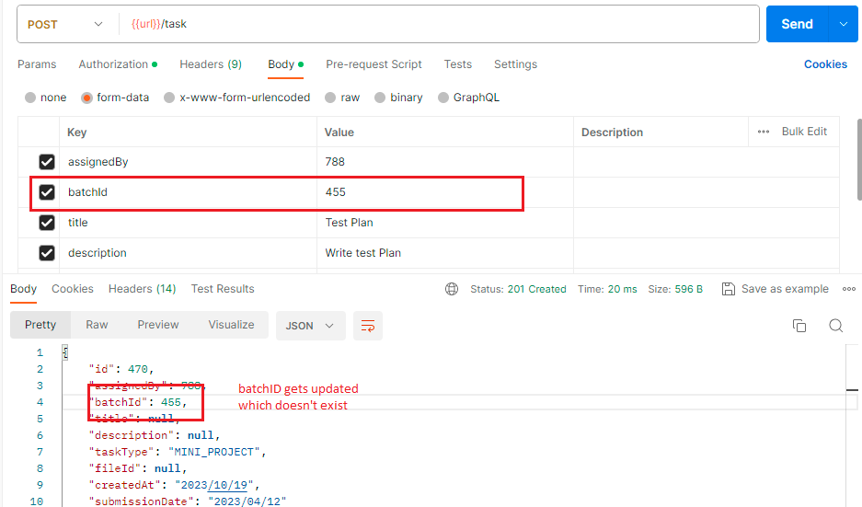

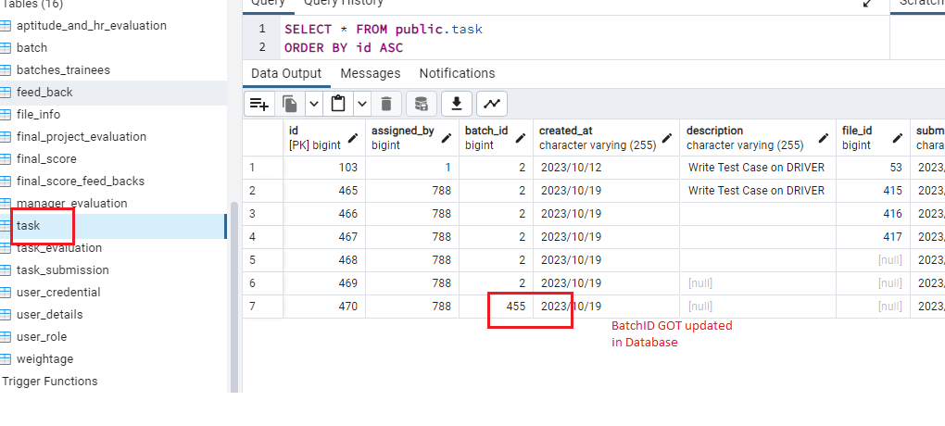

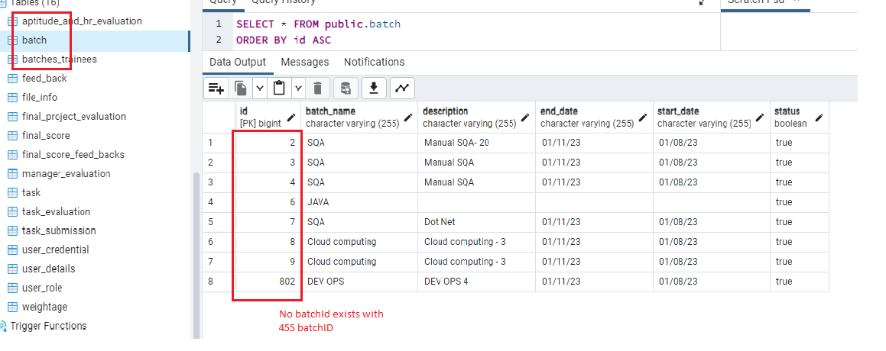

BugID: bug_06

[Upon creating a task using the API, the assignedBy input field takes non-existing user ID and also trainee user Id data from request body and gets updated in the database ]

**Description:**

**Package Name:** Task

**Module Name:** Create Task

**Method:** POST

**Endpoint:** /api/v1/task.

**Base URL:** http://localhost:8080/

*Environment *

OS: Windows 10 pro

Browser: Chrome Version 118.0.5993.71 (Official Build) (64-bit)

Build Date: 2023-10-19

**Pre-Conditions**

1. The system is up and running, and the API is accessible.
2. Admin/Trainer must be logged in

# Steps to reproduce

1. Send a POST request to the endpoint /api/v1/task.

2. Include valid data in the request body contain fields such as assignedBy, batchId, title, description, taskType, submissionDate, file

3. in assignedBy field Enter a user id that doesnt exist

# Expected Result

1. The task should only be assigned to The batches by admin and trainer only that exists and this field should take only the user id that exists and for invalid userID input it should show an error message indicating “userId not found” in the response body.

# 

# Actual Result

1. assignedBY field takes userID that does not exist

2. And get updated in the database with the non-existent batchID

**Attached Document:**

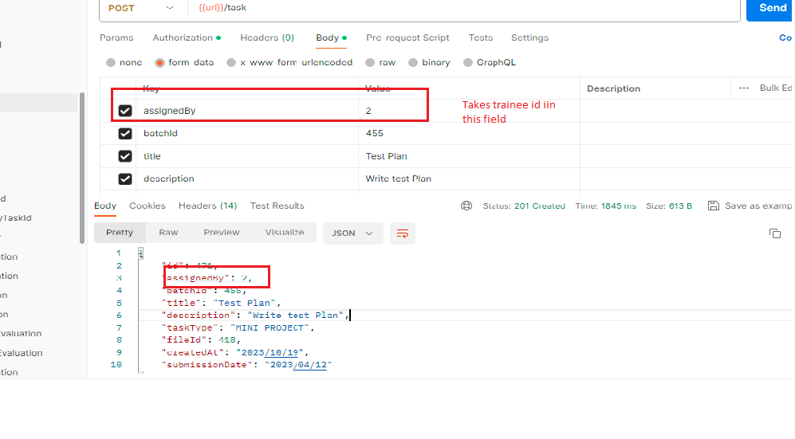

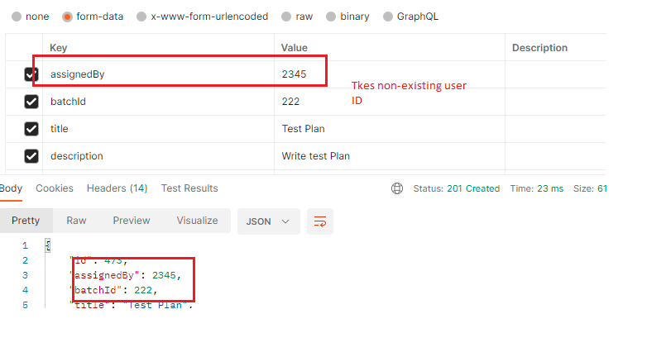

BugID: bug_07

[Upon creating a task using the API, the taskType input field takes non-existing task Type from request body and gets updated in the database ]

**Description:**

**Package Name:** Task

**Module Name:** Create Task

**Method:** POST

**Endpoint:** /api/v1/task.

**Base URL:** http://localhost:8080/

*Environment *

OS: Windows 10 pro

Browser: Chrome Version 118.0.5993.71 (Official Build) (64-bit)

Build Date: 2023-10-19

**Pre-Conditions**

1. The system is up and running, and the API is accessible.
2. Admin/Trainer must be logged in

# Steps to reproduce

1. Send a POST request to the endpoint /api/v1/task.

2. Include valid data in the request body contain fields such as assignedBy, batchId, title, description, taskType, submissionDate, file

3. in Task type field Enter a task type that does not exist in actual task type according to scope requirement

# Expected Result

1. The field should take only four task type (DAILY_TASK,MID_PROJECT, MINI_PROJECT, FINAL_PROJECT)

# 

# Actual Result

1. Task type field takes random data which are not in scope requirements and for invalid task type input it should show an error message indicating “invalid task type” in the response body

**Attached Document:**

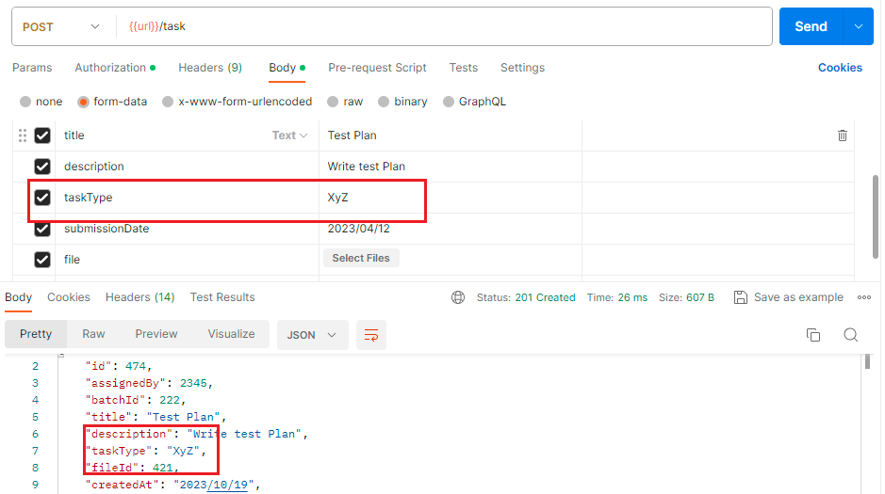

BugID: bug_08

[Upon creating a task using the API, the submissionDate input field takes a past date data from request body and gets updated in the database but submission of task date must be in future ]

**Description:**

**Package Name:** Task

**Module Name:** Create Task

**Method:** POST

**Endpoint:** /api/v1/task.

**Base URL:** http://localhost:8080/

*Environment *

OS: Windows 10 pro

Browser: Chrome Version 118.0.5993.71 (Official Build) (64-bit)

Build Date: 2023-10-19

**Pre-Conditions**

1. The system is up and running, and the API is accessible.
2. Admin/Trainer must be logged in

# Steps to reproduce

1. Send a POST request to the endpoint /api/v1/task.

2. Include valid data in the request body contain fields such as assignedBy, batchId, title, description, taskType, submissionDate, file

3. in submissionDate field Enter a past date

# Expected Result

1. Submission date should be in future, not in the past and for past date input it should show an error message indicating “can not input past Date” in the response body

# 

# Actual Result

1. Submission date takes date in the past

**Attached Document:**

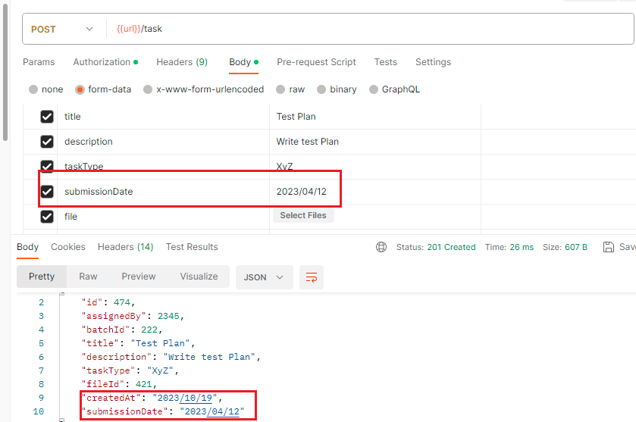

BugID: bug_09

[Generate score response body shows wrong status code when all required fields are not entered]

**Description:**

**Package Name:** Final Score

**Module Name:** Generate Score

**Method:** GET

**Endpoint:** /api/v1/final-score/{batchId}?recalculate={recalculate}

**Base URL:** http://localhost:8080/

**\*Environment \***

OS: Windows 10 pro

Browser: Chrome Version 118.0.5993.71 (Official Build) (64-bit)

Build Date: 2023-10-19

**Pre-Conditions**

1. The system is up and running, and the API is accessible.
2. Admin/Trainer must be logged in

# Steps to reproduce

1. Send a GET request to the endpoint /api/v1/final-score/{batchId}?recalculate={recalculate} where {batchId} is the ID of an existing batch and recalculate is a boolean value

2. Provide only batch id and keep the recalculate field empty

# Expected Result

1. The API should respond with a status code of 400 (Bad Request) since the required parameters are missing.

2. The response should contain an error message indicating the missing parameters.

# Actual Result

1. API and response body shows 403 FORBIDDEN

**Attached Document:**

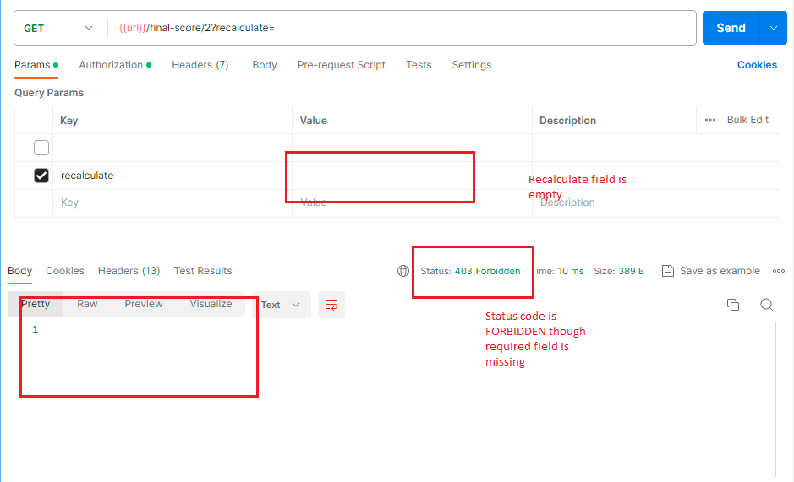

BugID: bug_10

[Generate score response body shows same output for entering different recalculate value ]

**Description:**

**Package Name:** Final Score

**Module Name:** Generate Score

**Method:** GET

**Endpoint:** /api/v1/final-score/{batchId}?recalculate={recalculate}

**Base URL:** http://localhost:8080/

**\*Environment \***

OS: Windows 10 pro

Browser: Chrome Version 118.0.5993.71 (Official Build) (64-bit)

Build Date: 2023-10-19

**Pre-Conditions**

1. The system is up and running, and the API is accessible.
2. Admin/Trainer must be logged in

# Steps to reproduce

1. Send a GET request to the endpoint /api/v1/final-score?recalculate=&batchId= where {batchId} is the ID of an existing batch and recalculate is a boolean value

2. Enter recalculate value in the path variables

3. Do the same steps for both boolean value of recalculate 2 times

# Expected Result

1. It should show different result against different input of recalculate value

# 

# Actual Result

1. t shows same result against both true and false input of recalculate value

**Attached Document:**

